Alfred Hitchcock’s Psycho
“Parlor scene”
Part I
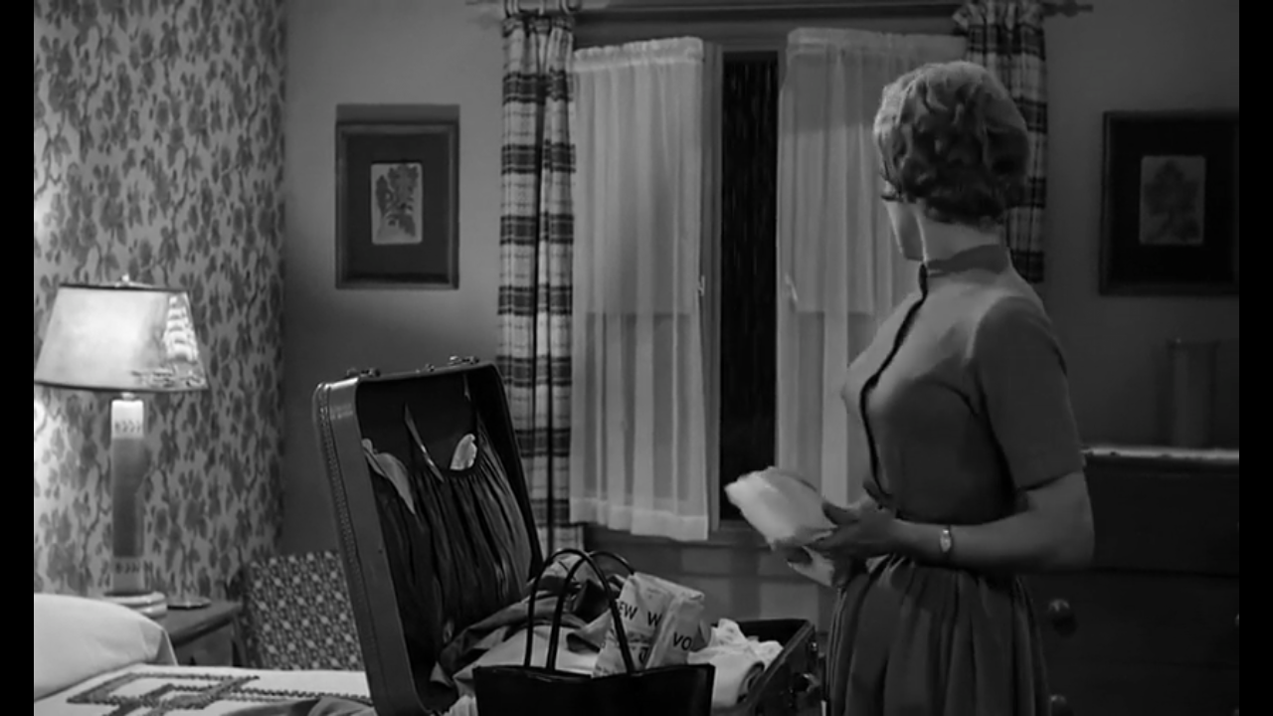
The Transition is cut to the next part. The shot is medium to eye level. Camera follows the movement of Marion. Lighting is from the lamp. Marion is in the foreground. Marion is stealing forty thousand dollars and hiding it in a newspaper
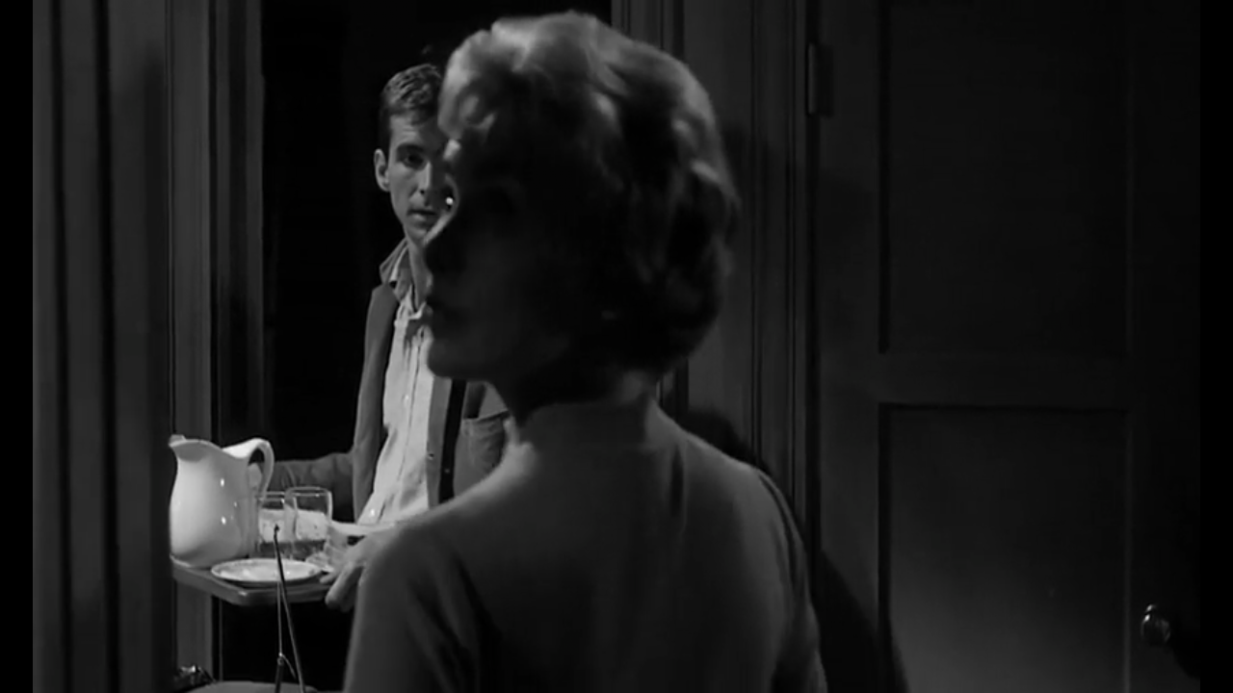
The transition is an invincible edit is immediately after the camera moves away from Marion and focuses on the bedroom. The camera is close up focusing on Marion. On the foreground is Marion and Norman is at the background inviting her into the parlor. Lighting is from an unknown source

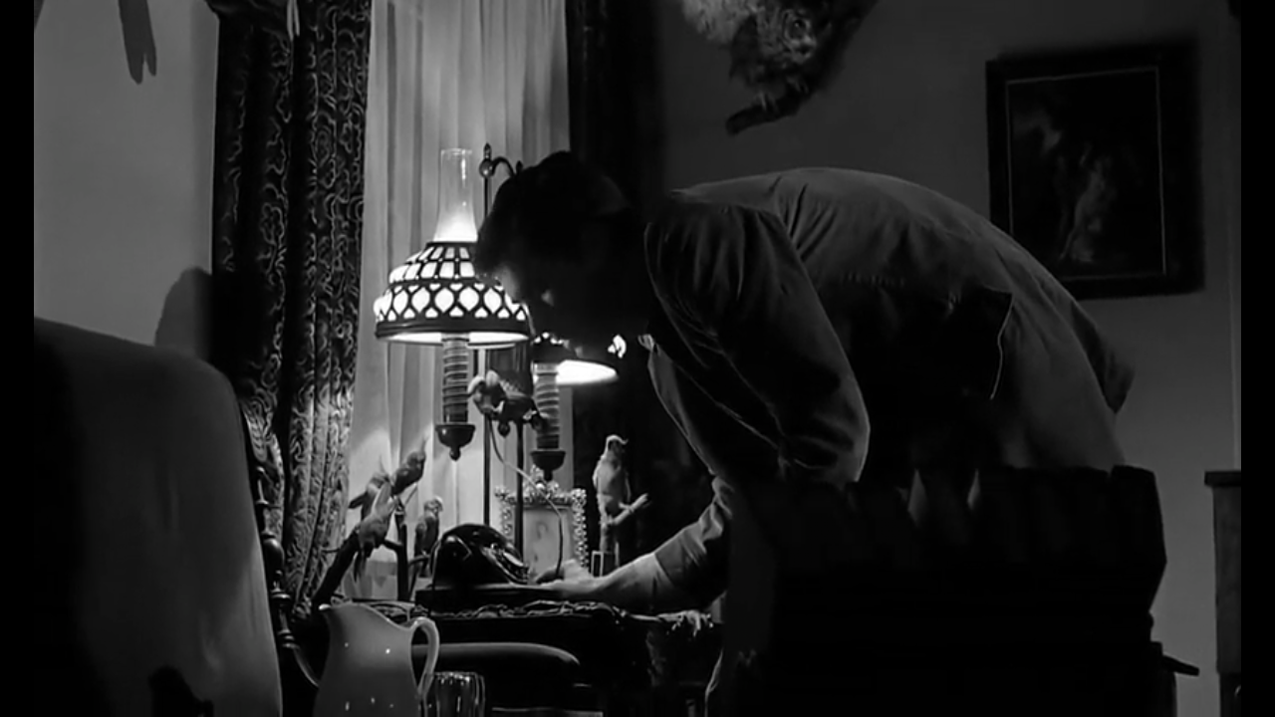
The transition into this scene is an invincible edit and there is a medium shot where the camera follows Norman into a dark room. In the foreground is Norman alone. The dark room becomes lit after the lamp on the table is lit. Norman Invites Marion to dine with him in the parlor.

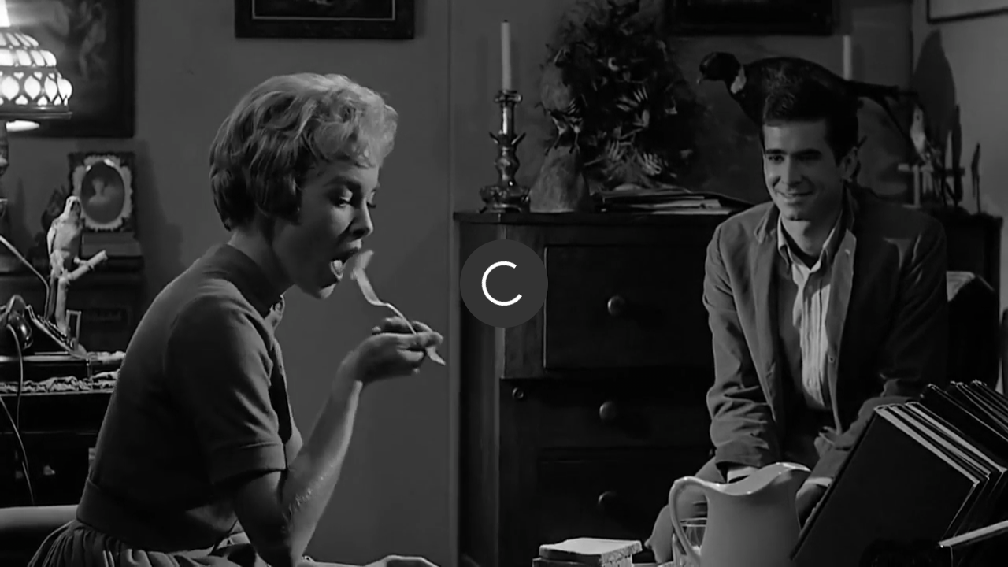
The next scene begins from an invincible cut transition; the angle of the camera is medium perhaps at eye level. The light in this scene is from a single lamp source. The image shows Marion at the foreground in the scene and at the back is Norman watching from a distance. Marion is eating the food as Norman sits back and engages in small talk.
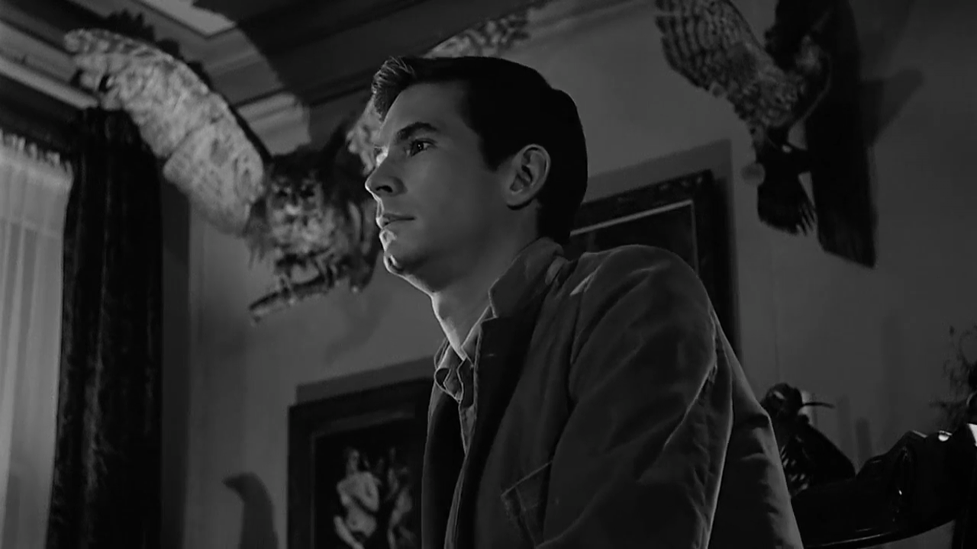
The transition is invincible cut immediately after Marion stops speaking. On the foreground is Norman while stuffed birds Owl in predatory motion is seen mounted on a wall. This part uses a close up shot
Notice the prop placement of the camera focusing on the owl in predatory motion where the audience notices that the birds behind his head is facing down staring at Marion. Norman gets agitated after Marion mentions to place his mother in “some place”

Part II
Introduction
Alfred Hitchcock’s Psycho acts as a milestone in the development of the horror films. Alfred uses cinematography to describe the mysterious. While viewing one of the most revealing scenes almost one third through the film, the intentions are visible. The main purpose of this reading is to review “Parlor scene” in Alfred Hitchcock’s Psycho using guidelines from his artistry, angle, camera, lighting mise-en-scene, and content.
The scene opens with shots of the exterior of the house while the next scene opens in the interior of the house. Clearly, there is an invincible edit immediately after the camera moves away from Marion and focuses on the bedroom. Close analysis of this section shows that there is a dissolve. This is the link that exists between the two shots.
The progression of the shots from the first shot is medium to eye level where the camera is seen to focus on the movement of Marion. The next shot as shown in the image is the close up shot of Marion as Norman is seen in the background. The next part after this is the camera being placed in medium level or eye level where Norman enters into a dark room and lights a lamp. In the Parlor, the room that is used to shoot the scene is small as it can barely accommodate two chairs. Marion is seen seated behind the lamp and her face is well lit. Despite the fact that she had stolen 40 thousand dollars, the scene leads the audience to view Marion in a positive light
It is until Marion enters Norman’s parlor is where a close-up view and a number of POV Shots of the stuffed animal that is the owl in predatory motion. Immediately after sitting down a two-shot of the characters is shown. It is the placement of the camera that portrays Norman as a predator. This is also evident from the prop placement where the audience notices that the birds behind his head are facing down staring at Marion
Hitchcock in creating his film he involves the use of camera angles in an effort to inform the audience of the troubled mind of Norman. The effect created is that the audience now sees Marion as two people may see each other when seated thus, creating a sense of normalcy and comfort. Alfred Hitchcock shoots Norman from an abnormally low perspective. The meaning comes off cleanly when the two are juxtaposed. This scene is interesting as it sets up a potential for danger that Norman’s reality is off balance.
The low angle shots as seen in Dinner as the camera cuts to stuffed animals mounted is clearly the use of shadows to show image power. The low angle shots make the audience to feel vulnerable. There are numerous reverse shots, and shots which were used in the conversation between Norman and Marion. There is also a period of close up shots of the birds. Marion stands and is filmed at low angle shot while Norman in high angle. This perhaps shows a change in power.
Conclusion
To sum up, the paper is a review of the “Parlor scene” in Alfred Hitchcock’s Psycho using guidelines from his artistry, angle, camera, lighting mise-en-scene and many more aspects in film production. The way in which the film is produced in a way the captures the heart of the audience to view Marion as an innocent lady while Norman as an unstable person who has different personalities.

